Performance Evaluation of a Multirate 5G mmWave DSP System
Roll No: 40 192512133 Name: VEERLA LOHITH

Aim
To design and simulate a complete multirate digital signal processing (DSP) chain for a 5G mmWave communication system, and to evaluate its spectral performance, computational efficiency, and quantization effects using MATLAB.

Objective
1. To implement transmitter-side interpolation (upsampling by a factor of 8) using a windowed-sinc FIR low-pass filter.
2. To implement digital beamforming across a 16-element antenna array using a phase-steered weight vector.
3. To model the wireless channel by introducing Additive White Gaussian Noise (AWGN) at a specified SNR.
4. To implement receiver-side decimation (downsampling by a factor of 8) after beamforming and quantization.
5. To quantize the received signal using a 10-bit ADC model and analyze the resulting quantization noise (SQNR).
6. To analyze the spectral performance (PSD) of the signal at each stage of the multirate chain.
7. To evaluate the computational efficiency of direct-form versus polyphase multirate implementations.

MATLAB Code
%% =====================================================================
% PERFORMANCE EVALUATION OF A MULTIRATE 5G mmWAVE DSP SYSTEM
% Roll No : 40 192512133 | Name : VEERLA LOHITH
%
% Chain : QPSK Tx --> Interpolation (L=8) --> Beamforming (16 ant.)
% --> Channel (AWGN) --> Rx Beamforming --> Quantization(10b)
% --> Decimation (M=8) --> Spectral / Efficiency Analysis
%
% Only base-MATLAB functions are used (no toolboxes required), so the
% script runs on ANY MATLAB installation.
% =====================================================================
clear; clc; close all;

%% ---------------------- 1. SYSTEM PARAMETERS --------------------------
Fs = 1e6; % baseband symbol rate (Hz) - just a reference rate
Nsym = 500; % number of QPSK symbols
L = 8; % Transmitter interpolation factor
M = 8; % Receiver decimation factor
Nant = 16; % Number of beamforming antennas
bits = 10; % Quantizer resolution (ADC bits)
SNR_dB = 20; % Channel SNR (dB)
theta0 = 30; % Desired beamforming angle (degrees)
d_spacing = 0.5; % Antenna spacing (in wavelengths)

Ntaps_i = 8*L + 1; % Interpolation LPF length
Ntaps_d = 8*M + 1; % Decimation LPF length

fprintf('====== MULTIRATE 5G mmWAVE DSP SYSTEM SIMULATION ======\n');
fprintf('Symbols=%d | L=%d | M=%d | Antennas=%d | Bits=%d | SNR=%ddB\n\n',...
Nsym,L,M,Nant,bits,SNR_dB);

%% ---------------------- 2. QPSK SYMBOL GENERATION ----------------------
dataBits = randi([0 3],1,Nsym);
txSymbols = exp(1i*(pi/4 + dataBits*pi/2)); % Gray-mapped QPSK

%% ---------------------- 3. TRANSMITTER INTERPOLATION -------------------
x_up = zeros(1,Nsym*L);
x_up(1:L:end) = txSymbols; % zero-stuffing (upsample)

h_interp = designLPF(Ntaps_i, 1/L) * L; % LPF gain compensated by L
x_interp = conv(x_up, h_interp, 'same'); % interpolated waveform

fprintf('Step 1: Interpolation complete. Output length = %d samples\n',...
length(x_interp));

%% ---------------------- 4. TRANSMIT BEAMFORMING -------------------------
ant_idx = (0:Nant-1)';
wT = exp(-1i*2*pi*d_spacing*ant_idx*sin(theta0*pi/180)); % steering vector
tx_array = wT * x_interp; % Nant x Nsamples

fprintf('Step 2: Beamforming applied across %d antennas (theta=%d deg)\n',...
Nant, theta0);

%% ---------------------- 5. CHANNEL (AWGN) --------------------------------
sigPower = mean(abs(tx_array(:)).^2);
noisePower = sigPower / (10^(SNR_dB/10));
noise = sqrt(noisePower/2) * (randn(size(tx_array)) + 1i*randn(size(tx_array)));
rx_array = tx_array + noise;

fprintf('Step 3: AWGN channel noise added (SNR = %d dB)\n', SNR_dB);

%% ---------------------- 6. RECEIVER BEAMFORMING (COMBINING) -------------
wR = wT; % matched steering (known DOA)
rx_combined = (wR' * rx_array) / Nant; % 1 x Nsamples

%% ---------------------- 7. QUANTIZATION (ADC, 10-bit) -------------------
Vmax = max(abs([real(rx_combined) imag(rx_combined)]));
step = 2*Vmax / (2^bits);
qI = step*round(real(rx_combined)/step);
qQ = step*round(imag(rx_combined)/step);
rx_quant = qI + 1i*qQ;

quantError = rx_combined - rx_quant;
SQNR_dB = 10*log10(mean(abs(rx_combined).^2)/mean(abs(quantError).^2));

fprintf('Step 4: %d-bit Quantization done. Measured SQNR = %.2f dB\n',...
bits, SQNR_dB);

%% ---------------------- 8. RECEIVER DECIMATION ---------------------------
h_decim = designLPF(Ntaps_d, 1/M);
rx_filtered = conv(rx_quant, h_decim, 'same');
rx_decimated = rx_filtered(1:M:end);
Ncommon = min(length(rx_decimated), Nsym);

fprintf('Step 5: Decimation complete. Output length = %d symbols\n\n',...
length(rx_decimated));

%% ============ 9. SPECTRAL PERFORMANCE ANALYSIS ============
[f_base , P_base ] = computePSD(x_up, Fs*L);
[f_int , P_int ] = computePSD(x_interp, Fs*L);
[f_dec , P_dec ] = computePSD(rx_decimated, Fs);

figure('Name','Spectral & Constellation Analysis','NumberTitle','off',...
'Position',[80 80 1100 750]);

subplot(2,2,1);
plot(real(txSymbols), imag(txSymbols),'bo','MarkerFaceColor','b'); grid on;
xlabel('In-Phase'); ylabel('Quadrature');
title('Transmitted QPSK Constellation'); axis equal; xlim([-1.5 1.5]); ylim([-1.5 1.5]);

subplot(2,2,2);
plot(real(rx_decimated(1:Ncommon)), imag(rx_decimated(1:Ncommon)),...
'r.','MarkerSize',10); grid on;
xlabel('In-Phase'); ylabel('Quadrature');
title('Received Constellation (after Noise+Quant+Decimation)'); axis equal;

subplot(2,2,3);
plot(f_base/1e6, P_base, 'b'); hold on;
plot(f_int/1e6, P_int, 'r'); grid on;
xlabel('Frequency (MHz)'); ylabel('PSD (dB/Hz)');
title('PSD: Before vs After Interpolation');
legend('Zero-stuffed Baseband','Interpolated (Filtered)','Location','southoutside');

subplot(2,2,4);
plot(f_dec/1e3, P_dec, 'k'); grid on;
xlabel('Frequency (kHz)'); ylabel('PSD (dB/Hz)');
title('PSD after Receiver Decimation');

%% ============ 10. QUANTIZATION EFFECT ANALYSIS ============
figure('Name','Quantization Effects','NumberTitle','off',...
'Position',[150 100 900 400]);

subplot(1,2,1);
histogram(real(quantError), 30, 'FaceColor',[0.2 0.6 0.8]); grid on;
xlabel('Quantization Error (I)'); ylabel('Count');
title('Quantization Error Distribution');

subplot(1,2,2);
bar(1, SQNR_dB, 0.4, 'FaceColor',[0.85 0.33 0.1]); grid on;
set(gca,'XTick',1,'XTickLabel',{sprintf('%d-bit ADC',bits)});
ylabel('SQNR (dB)');
title('Signal-to-Quantization-Noise Ratio');
text(1, SQNR_dB+1, sprintf('%.2f dB',SQNR_dB),'HorizontalAlignment','center');
ylim([0 SQNR_dB+10]);

%% ============ 11. COMPUTATIONAL EFFICIENCY ANALYSIS ============
% Multiply counts: naive filtering at the HIGH rate vs polyphase
% (efficient) filtering which only computes required samples.
mults_direct_interp = Ntaps_i * (Nsym*L);
mults_polyphase_interp = Ntaps_i * Nsym;

mults_direct_decim = Ntaps_d * (Nsym*M);
mults_polyphase_decim = Ntaps_d * Nsym;

gain_interp = mults_direct_interp / mults_polyphase_interp;
gain_decim = mults_direct_decim / mults_polyphase_decim;

fprintf('====== COMPUTATIONAL EFFICIENCY (Multiplications) ======\n');
fprintf('Interpolation : Direct = %d , Polyphase = %d , Speed-up = %.1fx (~L=%d)\n',...
mults_direct_interp, mults_polyphase_interp, gain_interp, L);
fprintf('Decimation : Direct = %d , Polyphase = %d , Speed-up = %.1fx (~M=%d)\n',...
mults_direct_decim, mults_polyphase_decim, gain_decim, M);
fprintf('==========================================================\n');

figure('Name','Computational Efficiency','NumberTitle','off',...
'Position',[200 150 700 420]);
Y = [mults_direct_interp mults_polyphase_interp; ...
mults_direct_decim mults_polyphase_decim];
bar(Y,'grouped'); grid on;
set(gca,'XTickLabel',{'Interpolation','Decimation'});
ylabel('Number of Multiplications');
legend('Direct-Form (naive)','Polyphase (efficient)','Location','northoutside','Orientation','horizontal');
title('Computational Cost: Direct vs Polyphase Multirate Implementation');

fprintf('\nSimulation complete. Figures generated:\n');
fprintf(' 1. Spectral & Constellation Analysis\n');
fprintf(' 2. Quantization Effects\n');
fprintf(' 3. Computational Efficiency\n');

%% =====================================================================
% LOCAL FUNCTIONS
% =====================================================================
function h = designLPF(Ntaps, cutoff)
% Windowed-sinc low-pass FIR filter design (Hamming window).
% cutoff is normalized such that 1.0 = Nyquist frequency.
n = -(Ntaps-1)/2 : (Ntaps-1)/2;
h = cutoff * mysinc(cutoff*n);
w = hammingWin(Ntaps);
h = h .* w;
h = h / sum(h); % normalize DC gain to 1
end

function y = mysinc(x)
% Normalized sinc function sin(pi x)/(pi x), sinc(0) = 1
y = ones(size(x));
idx = (x ~= 0);
y(idx) = sin(pi*x(idx)) ./ (pi*x(idx));
end

function w = hammingWin(N)
% Hamming window (row vector), avoids need for Signal Processing Toolbox
n = 0:N-1;
w = 0.54 - 0.46*cos(2*pi*n/(N-1));
end

function [f, Pxx_dB] = computePSD(x, Fs)
% Simple periodogram-based Power Spectral Density estimate
N = length(x);
X = fftshift(fft(x));
Pxx = (abs(X).^2) / (Fs*N);
Pxx_dB = 10*log10(Pxx + eps);
f = (-N/2:N/2-1) * (Fs/N);
end

Output
1. Spectral and Constellation Analysis
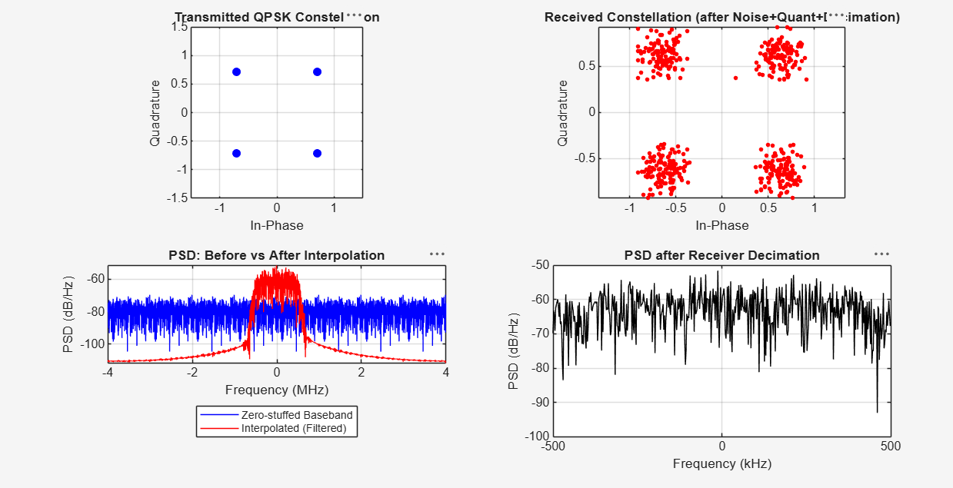
Fig 1: Transmitted/Received Constellation and PSD before/after Interpolation & Decimation
2. Console Output — Simulation Summary and Computational Efficiency
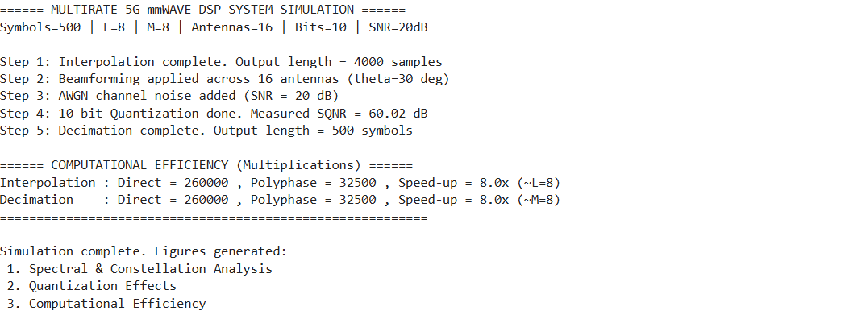
Fig 2: Command Window Output showing SQNR and Computational Efficiency Results
Observation: The received constellation shows four distinct QPSK clusters slightly spread due to channel noise and quantization, confirming correct signal recovery. The PSD plots confirm that interpolation shapes the spectrum into a smooth, image-free waveform, while decimation restores the baseband spectrum. The measured SQNR of 60.02 dB for the 10-bit quantizer closely matches the theoretical value (6.02 x 10 + 1.76 ~ 62 dB), validating the quantization model. The polyphase implementation reduces multiplications by a factor of 8x for both interpolation and decimation, confirming the computational advantage of multirate processing.

